Contents:
Importing Mocap Data
Attaching Motion to Skeleton
Attaching your model
Importing/Exporting animation data
Looping Motion Capture animation
Creating Animation Clips

Importing Mocap Data:
Motion capture data comes in lots of different file formats. However, not all of these formats work with Maya 2012. One format that does work is the .bvh, so those of you who want to use cmu’s mocap lab should tell Justin to give you the data in the .bvh format.
- Download and unzip bvhImportExport from CreativeCrash. You will have to make an account, but it is totally worth because the site is full of extremely useful scripts, shaders, rigs, models, textures etc and some of the good stuff is free http://www.creativecrash.com/maya/downloads/scripts-plugins/utility-external/export/c/bvh-file-import-export-for-maya/download_page
- Open the folder that corresponds with your version of maya and copy bvhImportExport.mll into your maya plugins folder . C:\Program Files\Autodesk\Maya2012\bin\plug-ins
- Copy the mel files to your project's scripts folder. To find this, open up one of your maya files and go to File->Project Window (or Edit Project if you're using an older version of maya).
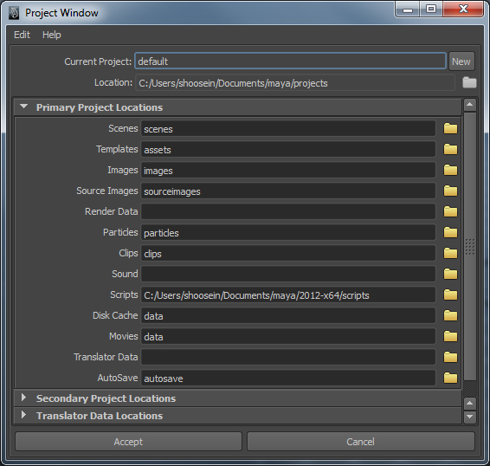

Find the row where it says Scripts. Next to it will be the name of the folder if it exists inside your project folder. Click on the folder next to the row to browse where you want your scripts to be. Copy the mel scripts into that folder.
- Go to the Plugin Manager in Maya. This is found under Window->Settings/Preferences->Plugin Manager.
- Click Browse and Open bvhImportExport.mll in the plugins folder. Click Refresh. If you did everything correctly, bvhImportExport.mll should appear in the plugins manager. You only have to Browse for the plugin once—the next time you open up Maya you just have to make sure Loaded is checked. If you don’t want to do this, check AutoLoad and the plugin will load automatically when you start up maya
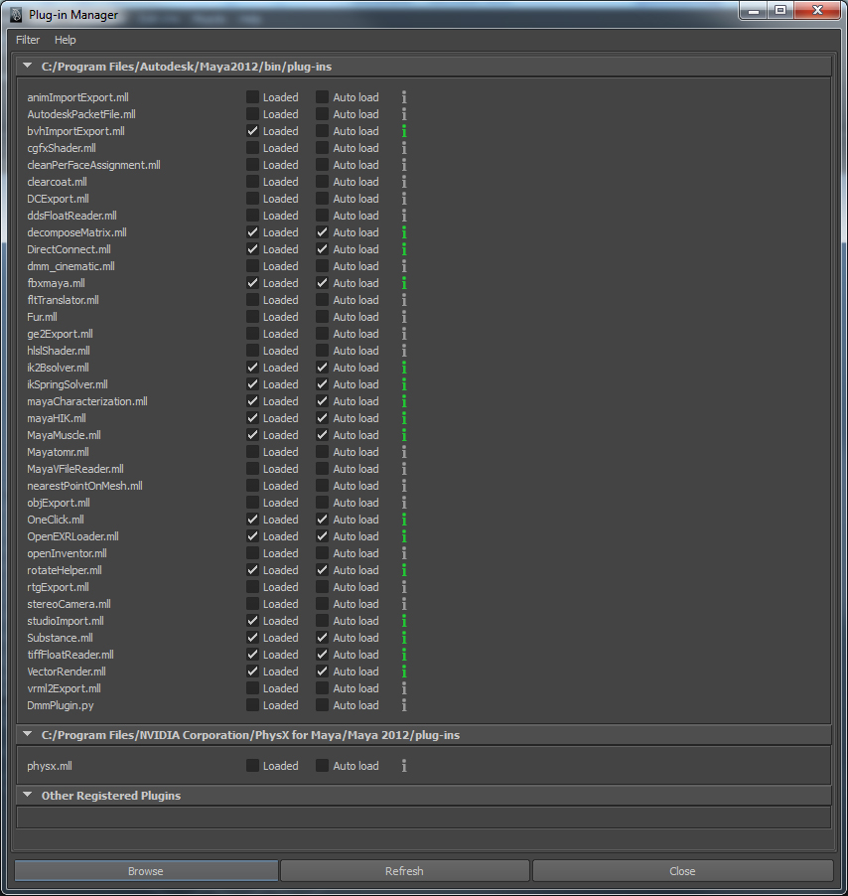

- Now go to File->Import and select either All Files/Best Guess or BVHimport. Your bvh will appear in the maya file.
Attaching Motion to Skeleton
Depending where you got your mocap data, the motion may already be attached to a skeleton or the skeleton file might be separate. Since it’s extremely important that the proportions of the skeleton match the motion data, make sure all your mocap data uses the same skeleton. The .bvh file format contains skeleton and motion data, so if you’re using that this section does not apply. If you are using the MayaVFileReader plugin and scripts (not yet available for Maya 2012), this will be useful.
- Go to Window->Settings and Preferences and change the units Maya is read in to be millimeter
- Go to your Vicon shelf and click the button to load the .vsk to import the skeleton
- Change the units to meters. Click button to load the .V motion file. If your model has not yet been attached from the skeleton, you want to select that ROM (range of motion) or the most complicated motion you’ll be using
- Go to Window->Outliner to open Maya’s Outliner menu
- Expand the motion tab. Parented to it are a set of markers and locators. Ignore the markers. For each locator, select it and its corresponding joint. In the animation shelf, click orient constraint
- Select the pelvis or root locator and joint. Click point constraint on the animations shelf.
- Do the same for the lowerback locator and joint.
- Select the joint in the skeleton highest in the hierarchy. Go to Edit->Keys->Bake, click on the square next to the Bake command to bring up the options menu. Make sure “Below” and “All keyable” are selected.
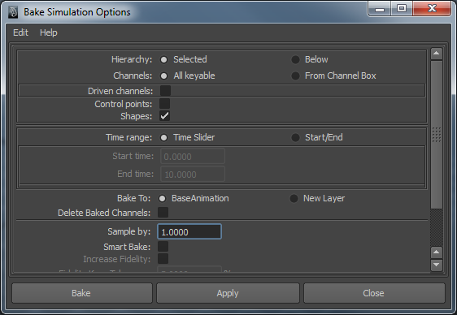

- Delete the motion file. If you scrub along the timeline, the skeleton should have the animation keyes on it and move around.
Attaching your model
When requesting motions from the mocap lab, make sure you also get a ROM (range of motion) file. This will include a t-pose that is natural for the actor, which means it’s also natural for your character.
- Attach the ROM motion to your skeleton
- Scrub along the timeline until to find the pose that is closest to the one your character was modeled in. Write down the keyframe of the pose so you find it again if you accidentally scrub or have to reopen the file.
- Adjust the proportions of your model so they match the proportions of the mocap skeleton. DO NOT MOVE THE JOINTS ON THE SKELETON!! Technically you can rotate the joints, but it is better to select vertices on your model and rotate them. Using the move tool on any joint other than the root (joint the others are parented to) will screw you up.

Use the soft select tool when moving/rotating vertices so your adjustments seem more natural. Turning on either Wireframe, Xray or Xray Joints will make it easier to see the skeleton once you’ve moved it inside your model.
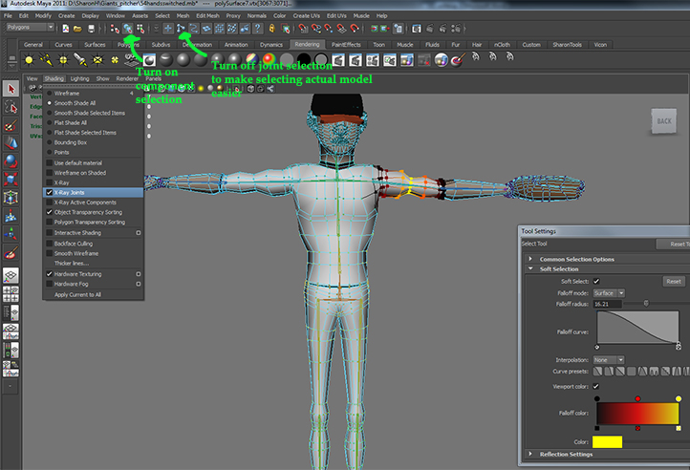

- Once you have the model and skeleton lined up the way you want, go to the Animate->Smooth Bind in the Animation menu set. From here, you will want to paint weights—which is a topic in itself I’m not going to cover right now.
- Delete all keyframe data on your skeleton. Depending on what file type your motion capture data is in you can either attach a new motion to your skeleton, or import an animation onto it.
Importing/Exporting animation data
Make sure animImportExport.mll is loaded in the Plugin Manager
To Export:
- Select the root joint of the skeleton
- Go to File and click on the square next to Export Selection in the drop down menu. Choose the file type to be animExport.
- Select “Below” and “All keyable”.

- Click “Export Selection” and choose the directory to save the .anim file
To Import:
- Make sure the skeleton you want to import animation onto has all the joints and objects that had animation data exported from the original skeleton. To be safe, make sure these joints and objects have the same name as they did in the original skeleton.
- Select the root joint
- Go to File and click on the square next to Import
- Next to “Files of type:” select animImport. Browse and select your anim file.
Looping Motion Capture Animation:
- Go to the first frame of the animation
- Right click on every joint and select “Set Preferred Angle”
- Go to the last frame
- Right click on every joint and select “Assume Preferred Angle”. Key the new rotation of the joint by pressing “s”
- Open the Graph Editor. Make sure the joints of your mocap-animation-to-be-looped are selected.
- Smooth the transition to the end of the loop. You can use a combination of these techniques:
  - You can extend the animation curves between any two keys by selecting the keys and pressing Shift while holding the middle mouse button to drag along the timeline
  - You can delete unimportant keys in front of the last key
  - You can change the shape of the animation curve by pressing the tangent buttons

Creating Animation Clips:
Once you’ve made your mocap data loop, you can create an animation clip to make it easier to reuse. To do this you will use the Trax Editor. There’s a lot of useful things you can do in the Trax Editor, including merging two clips together.
- Select the joints with the animation you want to create a clip from and open the graph editor.
- Select the keys to be included in your clip
- In the Animation menu set, go to Animate and click on the square next to Create Clip
- Select Put Clip in Trax Editor and Visor, Animation Curve and make sure Create time warp curve is unchecked. Then click Create Clip

- Next go to Window->Animation Editors and select Trax Editor.
- You can scroll your mouse to zoom in/out on your clip, or select your clip and then click on the button that shows two blue rectangles inside a white square to frame your selection.
- Right click on your clip and select Copy Clip. Right click behind it and select Paste Clip
- To make the clips flow together best, click and drag the pasted clip so it overlaps with the original by one frame. Then select both clips and click on the button that has a vertical green rectangle overlapping two horizontal blue rectangles to create a blend
- In the Trax Editor, select Edit->Merge
- Right click on the clip and check Activate Keys to show the keys in the timeline. When you don’t want to use the animation, you can uncheck this option

